TEMA EDI Billing

Overview
The EDI billing process with TEMA involves the transmission/reception of several EDI file types with TEMA. The words record and file can be interchanged when discussing EDI transmissions. By rule each file contains one EDI record. The EDI record/file types are:

- 856 ASN (Advance Shipping Notice) - Under normal EDI operations an ASN is sent prior to parts being shipped. In tire and wheel operations the ASN is sent to “load” or “initialize” the TEMA billing system with quantity of parts supplied. The TEAM EDI system has no connection to the TMM broadcast system. TEAM relies on the suppliers to bill correctly and accurately.
Edit to the ASN must be made prior to file being transmitted. Later updates are difficult and require a manual process.

- 824 Advice (Application Advice) – Error report from ASN submission. Although an ASN maybe accepted by TEMA, it still might contain errors that require the ASN to be resubmitted. Some items reported as error, such as “Cannot ASN o quantity parts” can be ignored. Errors are described in plain text.

- 810 Invoice (Accounts Receivable List) – The invoice file assigns the price to the quantity of parts that were shipped in the ASN.

- 820 Remittance (Remittance Advice) – Sent by TEMA once per month. Contains items paid by TEMA during the previous monthly billing cycle.

- 997 Acknowledgment (Functional Acknowledgment) - Each EDI record (856, 810) will be responded to by a 997. The 997 indicates whether the EDI file was accepted or rejected.

Billing Cycle
The daily billing workflow process follows a standard repeatable cycle:

- Shipping Pull
  - Manual adjustments
- Create ASN
  - Manual adjustments (match shipping)
  - Reconcile
- Create ASN File(s)
  - File loaded to outbound EDI directory
  - Automatic task send files to TEAM every 10 minutes
  - Automatic task retrieves response files every 10 minutes
- EDI Document Upload
  - Process 997’s
  - Process 824’s if present
    - Read 824 report from “Reports” directory
    - Fix required errors
    - Recreate ASN
    - Redo Step 4
- Create INVOICE File(s)
  - File loaded to outbound EDI directory
  - Automatic task send files to TEAM every 10 minutes
  - Automatic task retrieves response files every 10 minutes
- EDI Document Upload
  - Process 997’s
- Billing Cycle Complete!

ASN Create/Submit
Navigate to the Reports|Create ASN(856) menu selection. The ASN Create dialog will be displayed.
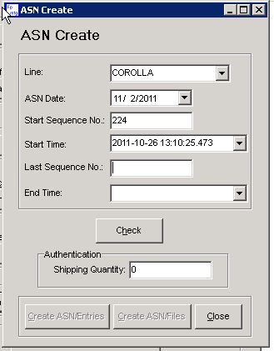

The starting sequence will contain the next sequence number since the last ASN that was created. Verify that this is the correct starting number. Also confirm the date for this number, as it is possible that multiple sequence number of the same value fall in the search time for dialog. (The search time is configurable in the File|Configuration menu)

The ASN Date field will contain the next available production day for an ASN. Only one ASN can be submitted for a production day.

Enter the ending sequence number, confirm that time, and press the check button. The shipping quantity should match the amount of vehicle sets during the time frame of the ASN. If not double check the start and end time and press the check button again.

When all values are confirmed press the Create ASN Entries button to add the entries to the database. Then press the close button.

If no edits are expected the next step can be omitted.

Navigate to the Master Data Maintenance|ASN/Invoice screen.

In the drop down “Status”, select NOT CREATED.

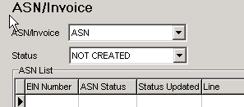

Any ASN’s that have not had files created will be available for viewing and editing. Use the controls in the bottom half of the page to select the items to update or delete from the ASN. The entire ASN can also be deleted from here as well.

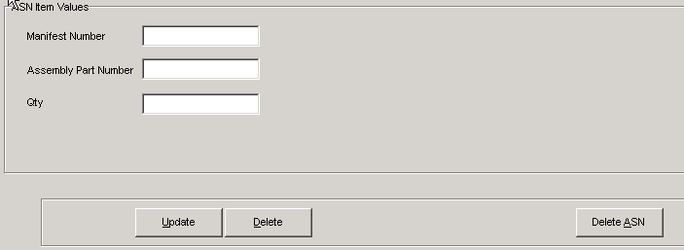

Navigate to the Reports|Create ASN(856) File{s) menu option. The Inventory System application will then place the ASN files in the outgoing EDI directory. (x:\EDIOut)

Waiting about 30 minutes will guarantee the send and receive tasks will have had time to run on the EDI computer. Alternately, check the incoming EDI directory (x:\EDIIn) for available files before moving to the next steps.

ASN Confirmation

To upload confirmation files from team, click the “EDI Document Upload” button on the application main screen. Any EDI files located in the Inbound EDI directory will be processed. The EDI upload will process any pending EDI files (Forecast, Remittance) , for this section only files pertaining to the ASN process are mentioned.

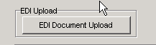

During processing, the EDI Upload dialog will display.

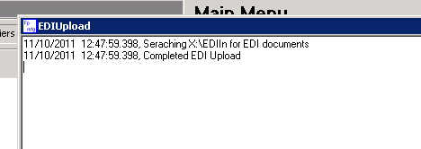

Two possible documents can be returned on the ASN EDI submission. Only one, the 997, is required and expected.

The 997 contains a single field that identifies if the ASN record was accepted. On import the application updated the status of the ASN in the database based on the 997 data. After import the update can be confirmed by navigating to the Master Data Maintenance |ASN/Invoice Dialog.
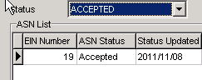

A second possible return on an ASN submission is an 824 Advice. If there is an issue with a line item in the ASN, TEMA will return this report. It’s expected that the line error will be corrected and the ASN resent prior to invoicing.

The 824 report will be available in the inventory reports directory.

ASN Edit/Recreate

To edit an already submitted ASN, navigate to Master Data Maintenance|ASN/Invoice dialog. Select ACCEPTED from the Status drop down. In the action button section at the bottom of the screen the Unsend ASN button will be available.

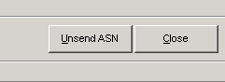

Pressing this button will update the ASN status to NOT CREATED.

The ASN can now be edited to fix any errors detected in the 824. Once edits are complete create the ASN files again for resubmission.

INVOICE Create/Submit

In the EDI process the ASN primes the TEMA billing system with the part quantities that have been shipped. While the Invoice ties prices to those quantities.

To create the invoice files navigate to the Reports|Create INVOICE(810) Files menu. Any previously ASN entries that have not been sent to invoice status will have an Invoice record created.

The TEMA EDI system will only reply to Invoice records with a 997. This will set the Invoice status to either accepted or rejected.

To verify the Invoice status, navigate to the Master Data Maintenance|ASN/Invoice dialog. Select Invoice from the ASN/Invoice drop down.

